SQL CAPSTONE PROJECT

WEEK 2

Dataset:

Client 3: Sports Stats (Olympics Dataset - 120 years of data)

SportsStats is a sports analysis firm partnering with local news and elite personal trainers to provide “interesting” insights

to help their partners. Insights could be patterns/trends highlighting certain groups/events/countries, etc. for the

purpose of developing a news story or discovering key health insights.

**Step 1: Descriptive Statistics On The Dataset**

1. Firstly, I found out the Average Height, Weight and Age of Medal Winners in each sport. This was in order to have better understanding of the data and information of the ideal body type for each sport.

SQL Query:

Output:

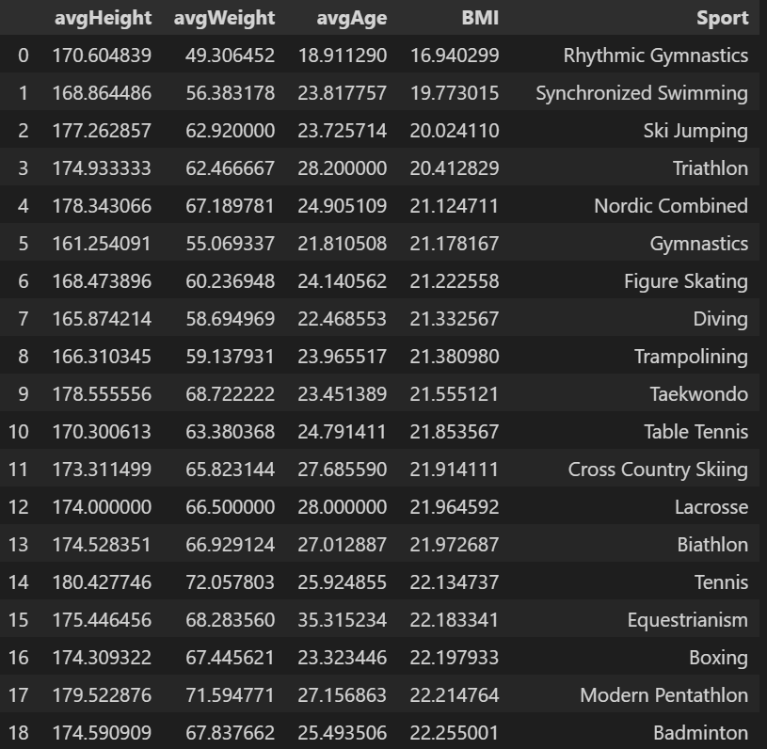

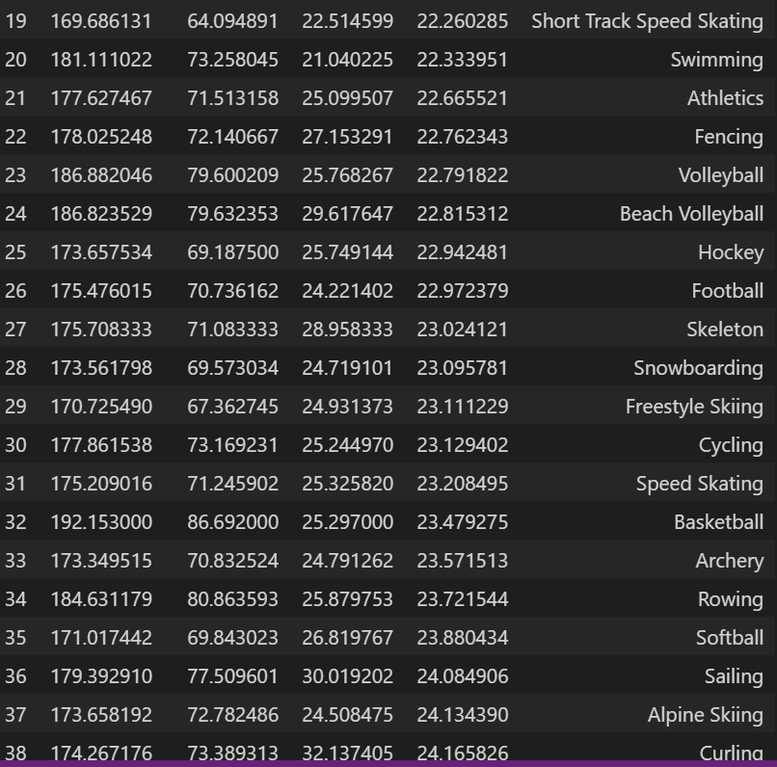

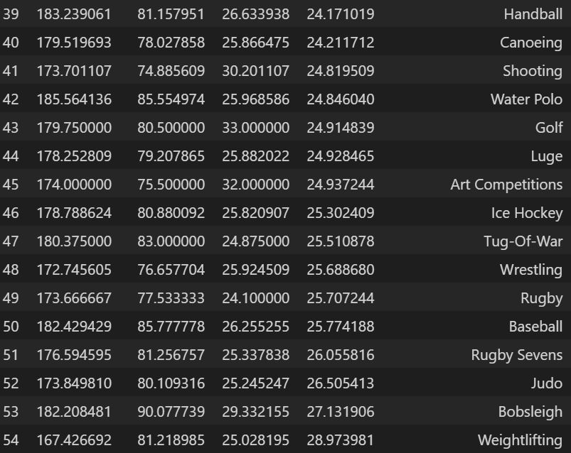

This was the result of that query.

This helped me answer the following questions:

1. The average height and weight characteristics for medal winners in each game

2. What is the average age of medal winners in each game

1. Secondly , I found out the total medals won by each country



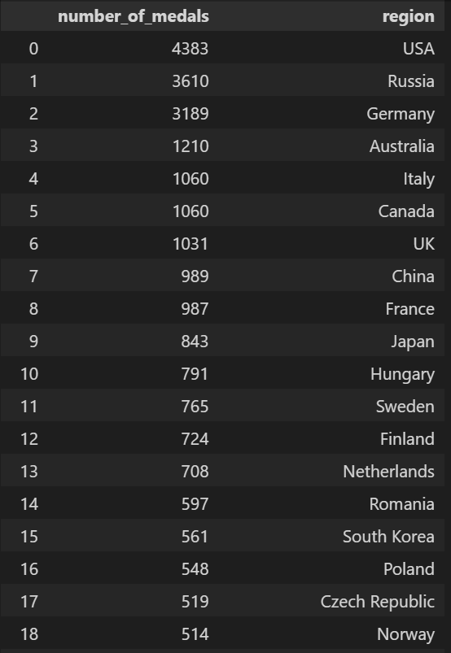

This query helped me understand which countries have won the most medals in the games.

1. Thirdly, I found out which country has won the most medals in each game and how many medals.



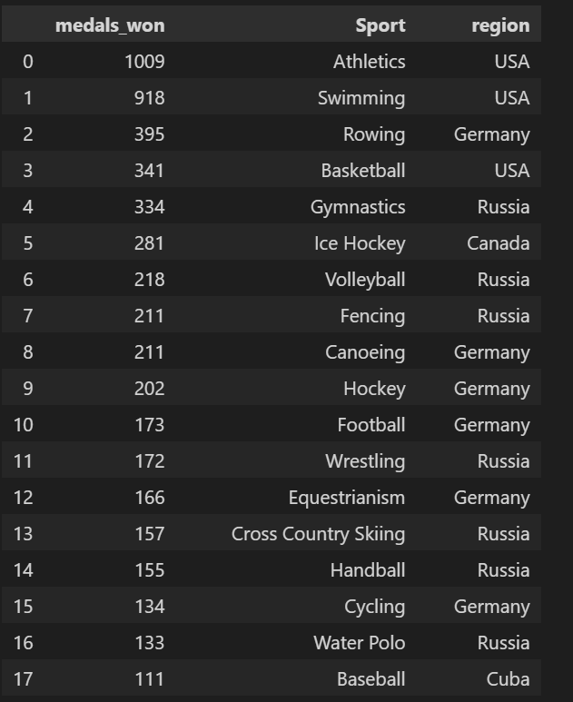

This helped me know which Country has won the most medals in each game

**Step 2: Key Points**

Key Points Discovered from The Data:

1. The BMI value of all athletes are ideal
2. Developed countries have won more medals in each sport
3. Developed countries have consistently won more total medals

**Step 3: Hypothesis Testing**

Hypothesis 1:

The average BMI value of the medal willing athletes matches with the ideal values

**Answer – This hypothesis turned out to be mostly true. For almost all the sports the average BMI value was between 18.5 to 24.9**

**However for Gymnastics, the BMI was lower than the normal value.**

**For sports like Wrestling, Tug of War, Weightlifting was more than the normal value.**

Hypothesis 2:

Developed countries have won more medals due to high infrastructure of sports.

**Answer – This hypothesis also turned out to be true. The developed countries such as Russia, Germany, USA, Australia, Canada, UK have consistently scored more medals.**

**The reason for this might be the fact that these countries provide better infrastructure for the sports and thus produce more and better athletes.**

**Step 4: Additional Questions**

How has the percentages of the genders playing each sport changed over the years?

Have more women started to play sports at the national level as the times progressed?